**NEWSPRISM**

**(ONLINE NEWS PORTAL)**

***A***

***Major Project Report***

***Submitted***

***In partial fulfillment***

***For the award of the Degree of***

**BACHELOR OF TECHNOLOGY**

***In Department of Computer science and Engineering***

**Submitted By: Guided By: Submitted To:**

NARESH MALI

ASHISH JAIN

TARUN TAILOR

KRISHNA GOSWAMI



**Department of Computer Science and Engineering**

**TECHNO INDIA NJR INSTITUTE OF TECHNOLOGY**

**RAJASTHAN TECHNICAL UNIVERSITY**

**May 2022**

**TECHNO INDIA NJR INSTITUTE OF TECHNOLOGY**



**CERTIFICATE**

This is to certify that this project report **“Online News Portal”** is the confide work of **“Naresh Mali, Ashish Jain, Tarun Tailor, Krishna Goswami”** who have carried out the project work under my supervision. I approve this project for submission of the Bachelor of Technology in the **Department of Computer Science and Engineering, Techno India NJR Institute of Technology**, affiliated to Rajasthan Technical University, Kota.

**Mr. Gaurav Kumawat Mr. Pankaj Chittora**

**Assistant Professor & Head Assistant professor, Project In charge**

**Department of Computer Science Department of Computer Science**

**ABSTRACT**

1. **Purpose**
   1. **Introduction**

The purpose of Online News Portal is to automate the existing manual system by the help of computerized equipments and full-fledged computer software, fulfilling their requirements, so that their valuable data/information can be stored for a longer period with easy accessing and manipulation of the same. The required software and hardware are easily available and easy to work with.

* 1. **Scope**

The online news portal system may serve a variety of purposes

Few of them are: -

* This portal is open to public and end user or customer can come here and browse the desired news.
* You don't have to wait for newspaper in morning.
* Any time any news related to different fields will be available.

1. **Document overview**

The remainder of this document is 8 chapters, the first providing introduction of the project. It lists all the functions performed by the system. The second chapter consists of software requirements specification. The third chapter provides details about system analysis and design. The fourth chapter gives data dictionary information. The fifth chapter consists of snapshots of the complete project. The sixth chapter gives testing for the project. The seventh chapter tells about the conclusion and future enhancements of the project. The final chapter concerns with the bibliography.

**ACKNOWLEDGEMENT**

It gives me immense pleasure to express my deepest sense of gratitude and sincere thanks to my highly respected and esteemed guide **Mr. Pankaj Chittora (Assistant Professor, Project In charge), TINJRIT** for their valuable guidance, encouragement and help for completing this work. Their useful suggestions for this whole work and co-operative behavior are sincerely acknowledged.

I would like to express my sincere thanks to **Mr. Gaurav Kumawat, Head of Department, Dept. of CSE TINJRIT** for giving me this opportunity to undertake this project.

I also wish to express my indebtedness to my parents as well as my family member whose blessings and support always helped me to face the challenges ahead.

At the end I would like to express my sincere thanks to all my friends and others who helped me directly or indirectly during this project work.

|  |  |  |  |  |  |
| --- | --- | --- | --- | --- | --- |
| **Place: Udaipur**  **Date:** |  |  |  |  | **Naresh Mali**  **Ashish Jain**  **Tarun Tailor**  **Krishna Goswami** |

**TABLE OF CONTENT**

**TITLE…………………………………………………………………….....1**

**CERTIFICATE…………………………………………………………….2**

**PREFACE ……………..……………………………………………………………………………..3**

**ACKNOWLEDGEMENT …………..……….………...………………….4**

**COMPANY PROFILE………………………………………………………………………….5**

**LIST OF FIGURE…..……………………………………………………...7**

**TABLE OF CONTENT……………………………………………………8**

**LIST OF CONTENT………………………………………………………8**

## LIST OF CONTENT

**S.NO. PAGE NO.**

1. **Introduction** 
   1. Introduction of Newsprism…………………….………….…………………10
   2. Functionality…………………………………………………………………10
   3. Why we need to make this website…………………………………………..11
   4. Purpose……………………………………………………………………….11
   5. Merits and Demerits of the project…………………………………………..11 **2. Tools & Methodologies**
   6. Node.js…………………………………………………………….…………12
   7. AngularJS…………………………………………………………………….13
   8. Express.js……………………………………………………………….……14
   9. MongoDB…………………………………………………………………...15
   10. Software Requirements....................................................................................15
   11. Hardware Requirements....................................................................................15
   12. Full Stack Developer Responsibilities………………………….……………16
   13. Full Stack Developer Requirements…………………………………………16

1. **Project Design** 
   1. Use case diagram............................................................................…..............17
   2. ER Diagram …………………………………………………….……………18
   3. Activity diagram………………………………………………………….......19
   4. Data flow Diagram ……………………………………………….………….20

1. **Project Profile** 
   1. Login Page.....................................................................................................21
   2. Index Page......................................................................................................22
   3. User Specification..........................................................................................23
      1. Business News..............................................................................................23
      2. Entertainment News......................................................................................24
      3. Health News..................................................................................................25
      4. Science News................................................................................................26
      5. Sports News..................................................................................................27
      6. Technology News.........................................................................................28
      7. Contact Us Page............................................................................................29
      8. Header……...................................................................................................29
      9. Footer……....................................................................................................30
      10. About Us Page............................................................................................30
2. **Conclusion & Future scope** 
   1. Conclusion...........................................................................................….......31
   2. Future scope ……………………….………………………….....................31
3. **References**................................................................................…......................32

**List of Tables**

# **List of Figures**

# **FIGURE NO. TITLE PAGE NO.**

|  |  |  |
| --- | --- | --- |
| Figure 2.1 |  | Concepts of Node.js………………….……..............................................11 |
| Figure 3.1 |  | Use Case for Admin Pane………………….…….....................................15 |
| Figure 3.2 |  | Use Case for User Panel............................................................................15 |
| Figure 3.3 |  | E-R Diagrams.............................................................................................16 |
| Figure 3.4 |  | Activity Diagram.......................................................................................17 |
| Figure 3.5 |  | 0 Level DFD..............................................................................................18 |
| Figure4.1 |  | Login Page……………………………………………………………….19 |
| Figure4.2 |  | Home Page………………………………………………………………20 |
| Figure4.3 |  | Business News Page…………………………………………………......21 |
| Figure4.4 |  | Entertainment News Page……………………………………………......22 |
| Figure4.5 |  | Health News Page ……………………………………………………….23 |
| Figure4.6 |  | Science News Page ……………………………………………………...24 |
| Figure4.7 |  | Sports News Page ……………………………………………………….25 |
| Figure4.8 |  | Technology News Page ………………………………………………….26 |
| Figure4.9 |  | Contact Us Page………………………………………………………….27 |
| Figure4.10 |  | Header……………………………………………………........................27 |
| Figure4.11 |  | Footer…………………………………………………………………….28 |
| Figure4.12 |  | About Us Page…………………………………………………………...28 |

**List of Symbols**

CHAPTER – I

INTRODUCTION

**INTRODUCTION**

#### **1.1. Introduction of Newsprism**

* The project Online News Portal aims at establishing a complete portal for providing news. This portal can provide up-to-date news information on the Internet. The portal will reside of sections addressing different information needs. It informs, provides extensive resources and services online for the general public. It provides a vast range of new opportunities for feedback, customization of content instant publishing, linking, articles etc. It is concerned with the development of a system.
* This project admin post latest news. User can view latest news category wise like Bollywood, Movies, Business, National, International, Entertainment, Sports news etc. The online news portal system may serve a variety of purposes. This system provides many newspapers: headlines and links to important national — and maybe local — news, weather forecasts, the day’s prime time television listing, stock market reports, and sports headlines. In this system we can provide a special feature such as COVID-19 tracker.
* This system can save times for users. It can also give the information about entertainment news, health news, dating and romance tips, a horoscope, trending topics, hyperlinks to related sites, a search engine, and sometimes free, web-based email. This Online News Portal System provides users read latest news online.
* The main aim of this project is to develop a newspaper where everyone of a society can read recent news, events, educational things, sports etc. This system is providing up-todate news information of our city. Editor and journalist identity is scrutinized and then the news is uploaded.
* Without any payment or login he/she can also contact us to give suggestions and can also give us feedback related to our site.
* New news can be added or post by the admin and only admin have the authorized to update or delete any news.
* Admin have to right to give authority to other for insert, update and delete the news.

**1.2. Functionalities provided by Online News Portal are as follows:**

* Provides the searching facilities based on various factors. Such as News, Latest News, Weather News, Bollywood News
* Online News Portal also manage the News Report details online for Weather News details, Bollywood News details, News.
* It tracks all the information of Category, News Report, Weather News etc
* Manage the information of Category
* Shows the information and description of the News, Latest News
* To increase efficiency of managing the News, Category
* It deals with monitoring the information and transactions of Weather News.
* Manage the information of News
* Manage the information of Weather News
* Integration of all records of Bollywood News.

**1.3. Why we need to make this website?**

* The main objective of this website is that to provide the all type of instant and important news related to Magazine, Business, Sports, Art, Politics, Travel, breaking news, etc.
* Manage the information of Magazine, Business, Sports, Art, Politics, Travel, Breaking news.
* Integration of all records of news.
* Those people who don’t have time to read the newspaper and always linked with internet can get more informative.
* Publish news about local region, town and city, national and international. End user can upload news from anywhere at any time through web, mobile, tables, etc. with registered their login id and password.

**1.4. Purpose**

* This portal is open to public and end user or customer can come here and browse the desired news.
* You don't have to wait for newspaper in morning.
* Any time any news related to different fields will be available.

**1.5. Merit and Demerits of the project:**

**Merits:**

* Extremely fast news.
* Flexible to access.
* Completely free.
* No personal information required.
* Interactive news.
* Environmentally friendly.
* Quick and easy way to get the news.
* Provides details efficiently.
* User friendly interface.
* Availability of multiple categorized News at one place at same time.
* Any time any news related to different fields will be available.

**Demerits:**

* Not accessible in some part of the world.
* Difficult to navigate the internet.
* Only those persons can use this website who know the basic computer knowledge.

**1.6 Reports of Online News Portal**

* It generates the report on News, Category, News Report
* Provide filter reports on Latest News, Weather News, Bollywood News
* You can easily export PDF for the News, News Report, Weather News
* Application also provides excel export for Category, Latest News, Bollywood News
* You can also export the report into csv format for News, Category, Bollywood News

**1.7 Modules of Online News Portal:**

* News Management Module: Used for managing the News details.
* Bollywood News Module: Used for managing the details of Bollywood News
* News Report Module: Used for managing the details of News Report
* Category Management Module: Used for managing the information and details of the Category.
* Latest News Module: Used for managing the Latest News details
* Weather News Module: Used for managing the Weather News information
* Login Module: Used for managing the login details
* Users Module: Used for managing the users of the system

CHAPTER – II

SOFTWARE REQUIREMENT SPECIFICATION

CHAPTER – III

SYSTEM ANALYSIS AND DESIGN

**System Analysis and Design**

#### **3.1. Use Case Diagram**

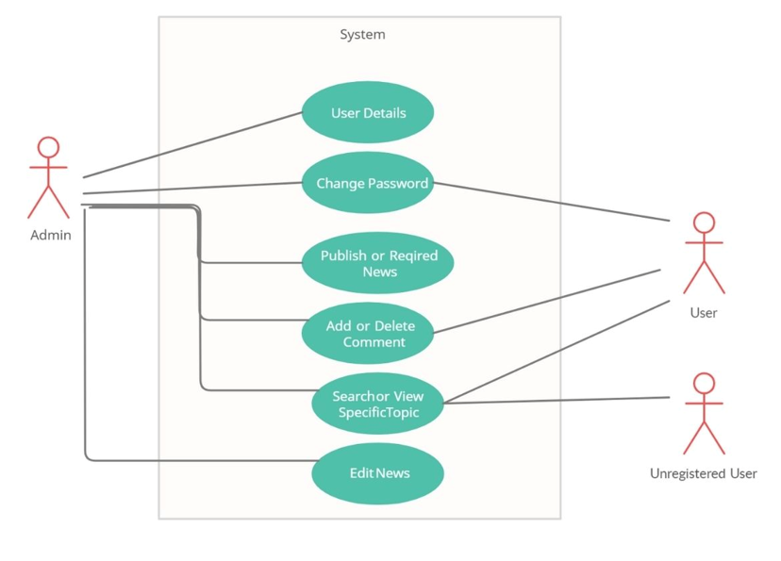

**Use Case Diagram for Admin**



**Login**

**Access**



**Upload**

**Function**



**Perform**

**Queries**

##### Fig 3.1 - For Admin Panel

##### **:**

1. The admin just needs to have login access.
2. Upload functions (with textbox and button).
3. Upload news, along with an image. Update news, images, Delete news and images.
4. Upload photos for gallery by dates with a hyperlink to enlarge and Delete button.
5. Upload videos (with textbox and button) and if can download you see.
6. Delete members the news we will upload it, just give us the layout and functionalities.

**Use Case Diagram for User**



**Open**

**Website**



**Read**



**Contact**

##### **Fig 3.2 - For User Panel**

1. Login as user and see the news.
2. Read the news category wise
3. Contact to admin if any requirement

**Context Diagram:**

A context diagram, sometimes called a level 0 data-flow diagram, is drawn in order to define and clarify the boundaries of the software system. It identifies the flows of information between the system and external entities. The entire software system is shown as a single process.

##### **Fig 3.3 – Context Diagram**

#### **3.3. Activity Flow Diagram**

An activity diagram used to model a large activity’s sequential work flow by focusing on action sequences and respective action conditions. An activity diagram is represented by shapes that are connected by arrows. Arrows run from activity start to complete and represent the sequential order of performance activity. In this rectangle represents performances action, and described by text inside each rectangle. In this circle represents an initial workflow state or an end state. In this diamond shape is used shape is used to represents a decision, which is key activity diagram concept.

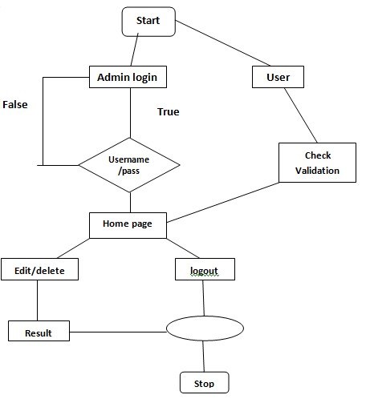

**Fig 3.4 – Activity Diagram**

#### **3.4. DFD (Data Flow Diagram)**

A DFD is a graphical representation of the “flow” of data through an information system, modelling its process aspects. A DFD is often used as a preliminary step to create an overview of the system without going into great detail, which can later be elaborated DFDs can also be used for the visualization of data processing (structured design).

A DFD shows what kind of information will be input to and output from the system, how the data will advance through the system, and where the data will be stored. It does not show information about the timing of process or information about whether processes will operate in sequence or in parallel unlike a flowchart which also shows this information.



**User**



**Website**



**Server**



**View Website**



**Request**



**Response**

##### **Fig 3.5 – 0 Level Data Flow Diagram**

This is a 0 Level Data Flow Diagram of the online news portal. In this DFD, user can see the news and website will send request to server and server gives respond of that request. In this diagram the portal accommodates three entities that are as follows:

* User
* News Website
* Server response

CHAPTER – IV

DATA DICTIONARY

**Data Dictionary**

.A data dictionary is a catalog-a-repository of the elements in a system. As the name suggests, their elements centre on data and the way they are structured to meet user requirements and organization needs. In a data dictionary you will find a list of all the elements composing the data flowing through a system. The major elements are data flows, data stores and processes. The data dictionary stores details and descriptions of these elements.

If analysis want to know characters are in a data item by what other names it is referenced in the system, or where it is referenced in the system, or where it is issued in the system, they should be able to find the answers in issued in the system, they should be able to find the answer in properly developed data dictionary.

The Dictionary contains two types of description for the data following through the system.

1. Data Elements

The most fundamental data is the elements. They are building blocks for all other data in the system. Data elements are also alternatively known as fields, data item or elementary item.

1. Data Structure

A data structure is a set if items that are related to one another and described a components in the system.

**4.1. E-R Diagram**

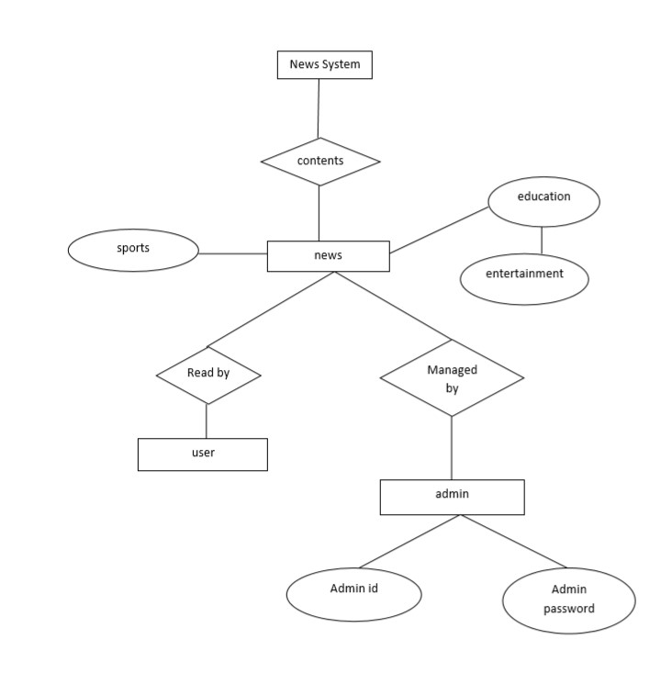

CHAPTER – V

SCREEN SHOTS

# PROJECT PROFILE

## 4.1. Login Page

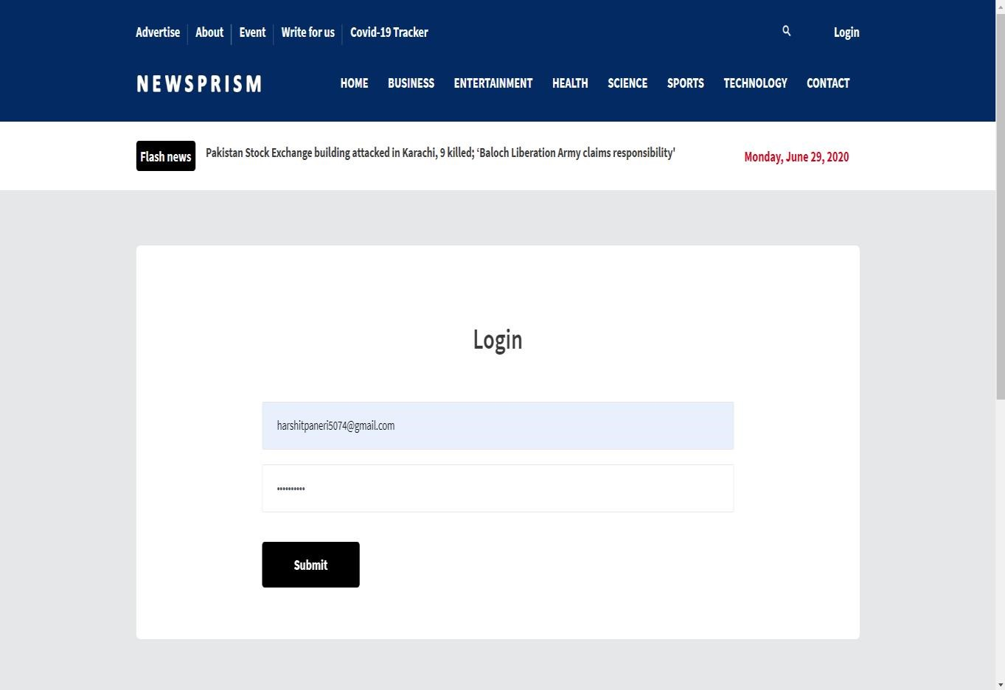

### Fig 4.1 – Login Page

The login page allows a admin to gain access to an application by entering their username and password.

## 4.2. Index Page

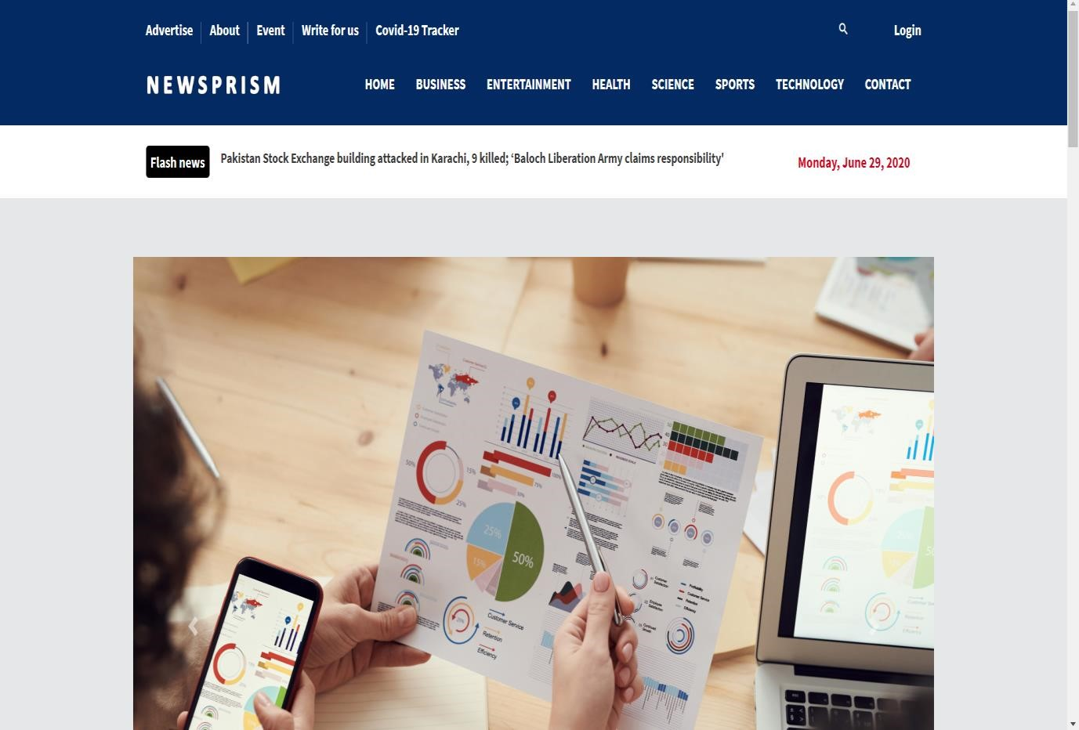

### Fig 4.2 – Index Page

* The home page is the name of the main page of a website where visitors can find hyperlinks and functionality to find other pages.
* Visitor navigating to a website from a search engine will see.
* It may also serve as a landing page to attract visitors.

## 4.3. User Specification

➢ **Business News**

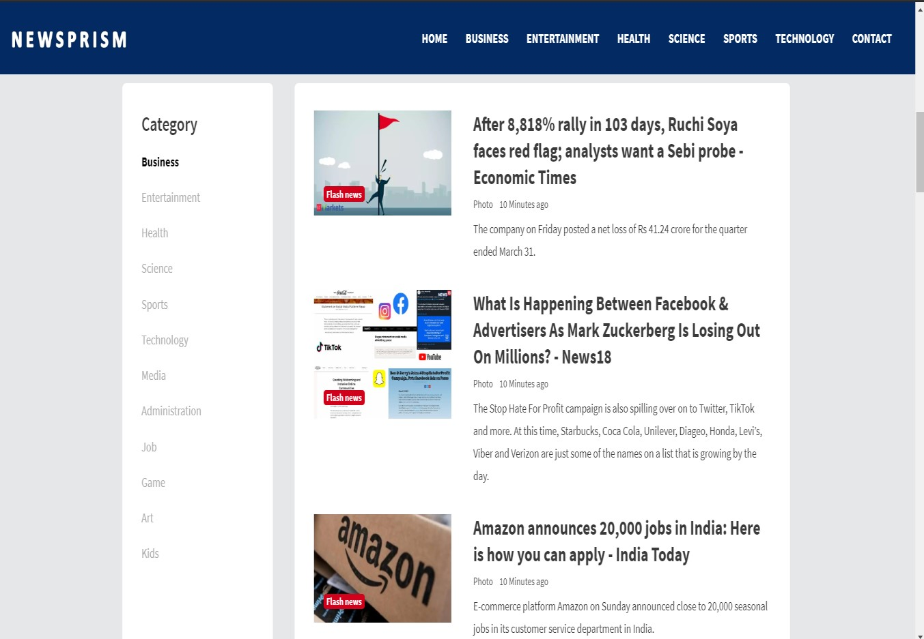

### Fig 4.3 – Business News Page

**Business** journalism is the part of journalism that tracks, records, analyzes and interprets the **business**, economic and **financial** activities and changes that take place in societies. This area of journalism provides **news** and feature articles about people, places and issues related to the **business** sector.

**Entertainment News**

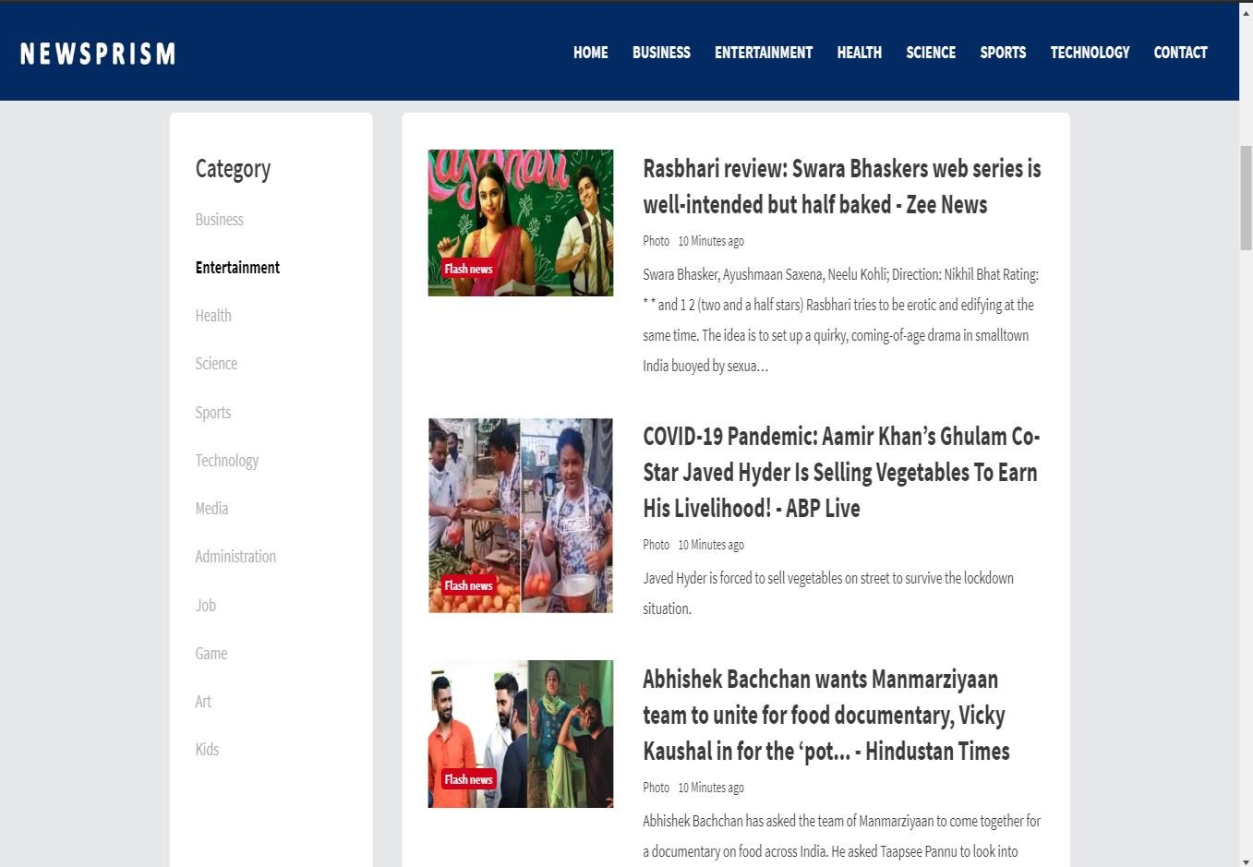

### Fig 4.4 – Entertainment News Page

Entertainment News is a flagship television news Entertainment program formatting infortainment which contains interesting news from the world of entertainment at home and abroad based on facts and information that broadcasts on the Indonesian TV station NET. This program also discusses news from the world of music, film, fashion, art, biography and event organizers.

**Health News**

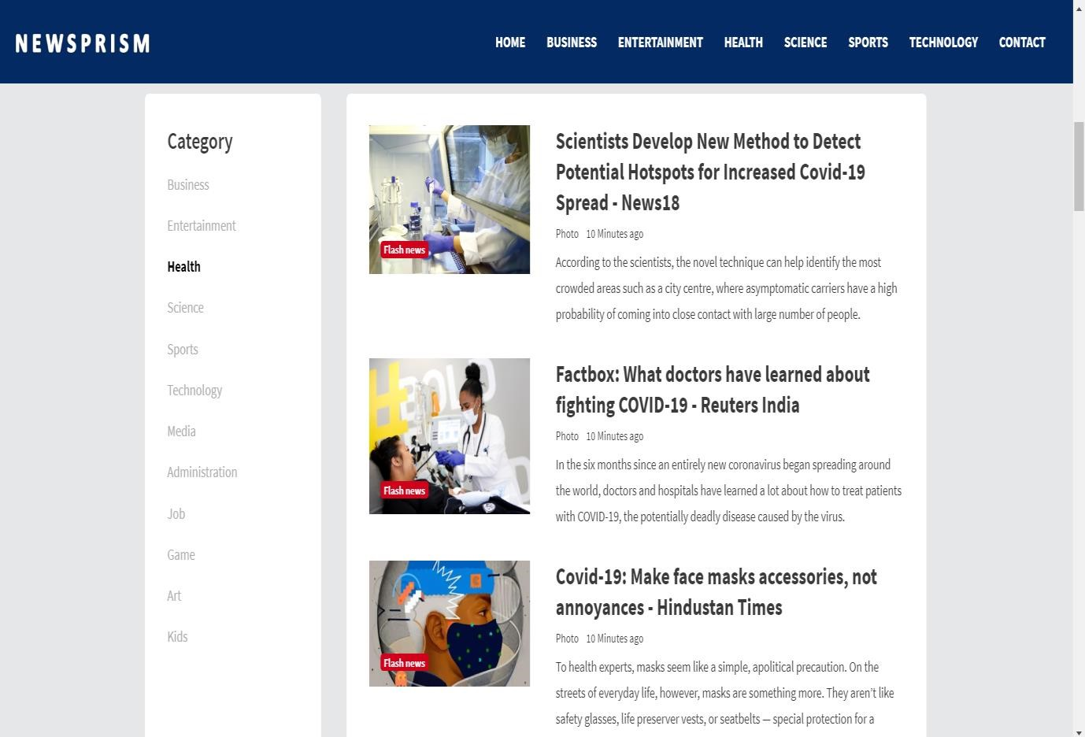

### Fig 4.5 – Health News Page

The latest health and wellness news, including case studies, research breakthroughs, celebrity health updates, and internet trends. After all, staying in the know is part of a balanced lifestyle.

**Science News**

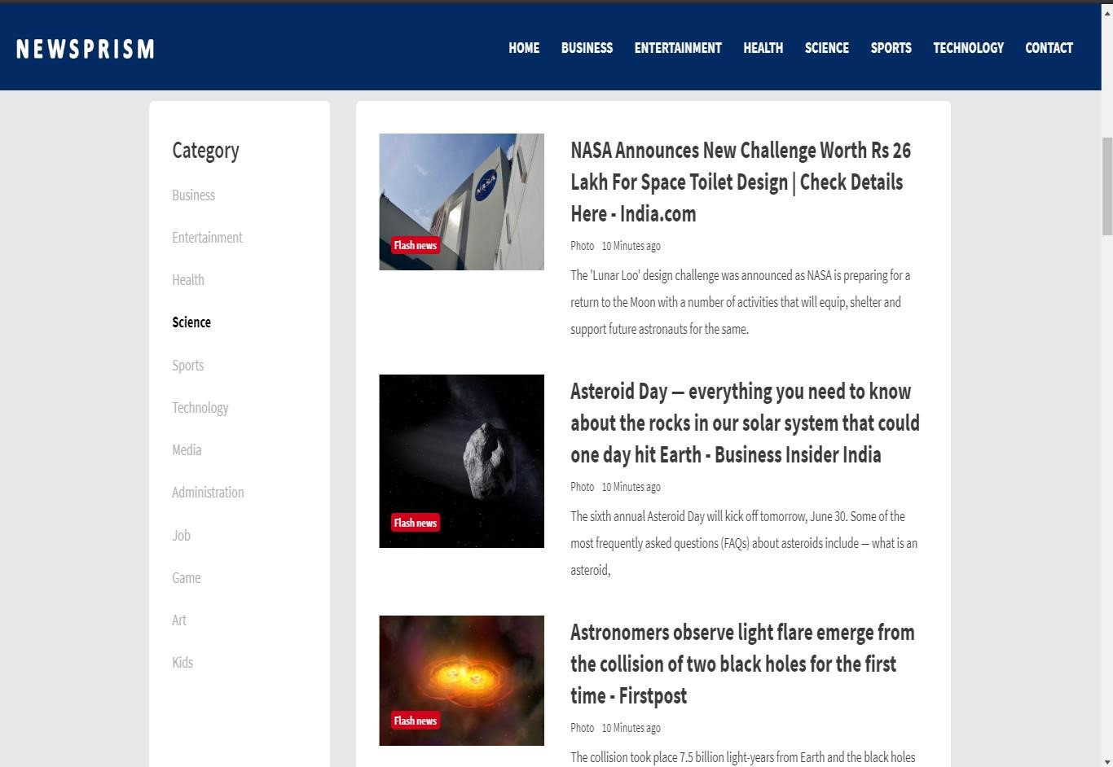

#### Fig 4.6 – Science News Page

Daily updates of the latest science news, new scientific research, technology breakthroughs, and how the science headlines affect you.

**Sports News**

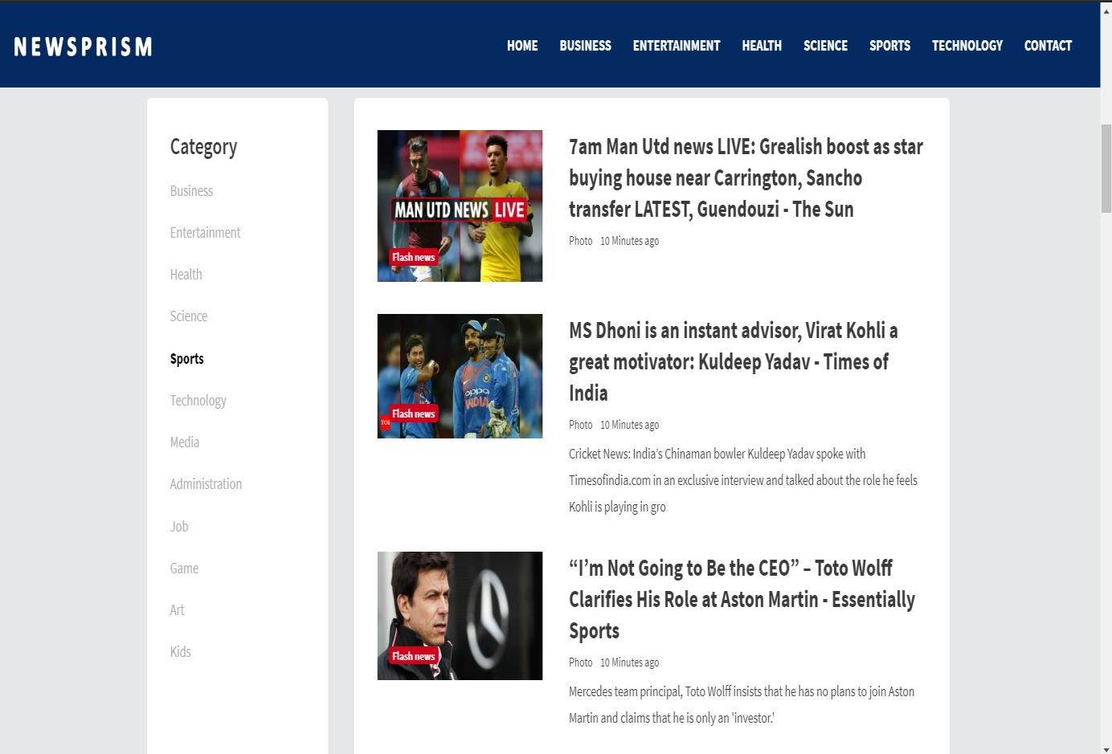

#### Fig 4.7 – Sports News Page

Sports journalism is a form of writing that reports on matters pertaining to sporting topics and competitions. Sports Journalism started in the early 1800s when it was targeted to the social elite and has transitioned into an integral part of the news business with newspapers having dedicated sports sections.

**Technology News**

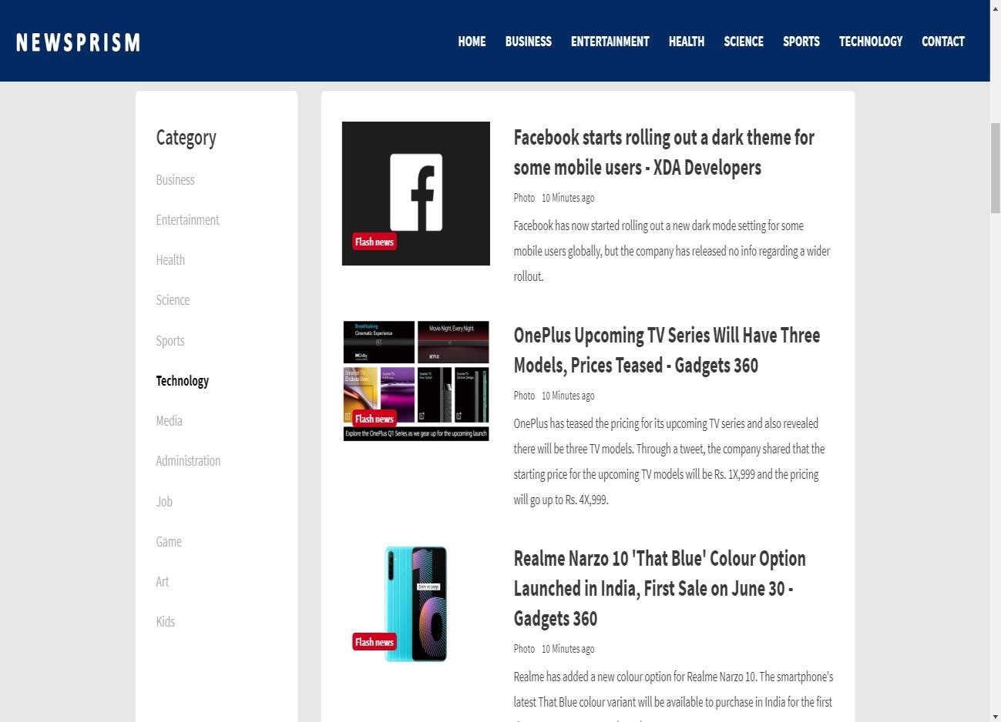

#### Fig 4.8 – Television News Page

The latest tech news about the world's best (and sometimes worst) hardware, apps, and much more. From top companies like Google and Apple to tiny startups vying for your attention, the latest in what matters in technology daily.

**Contact Us**

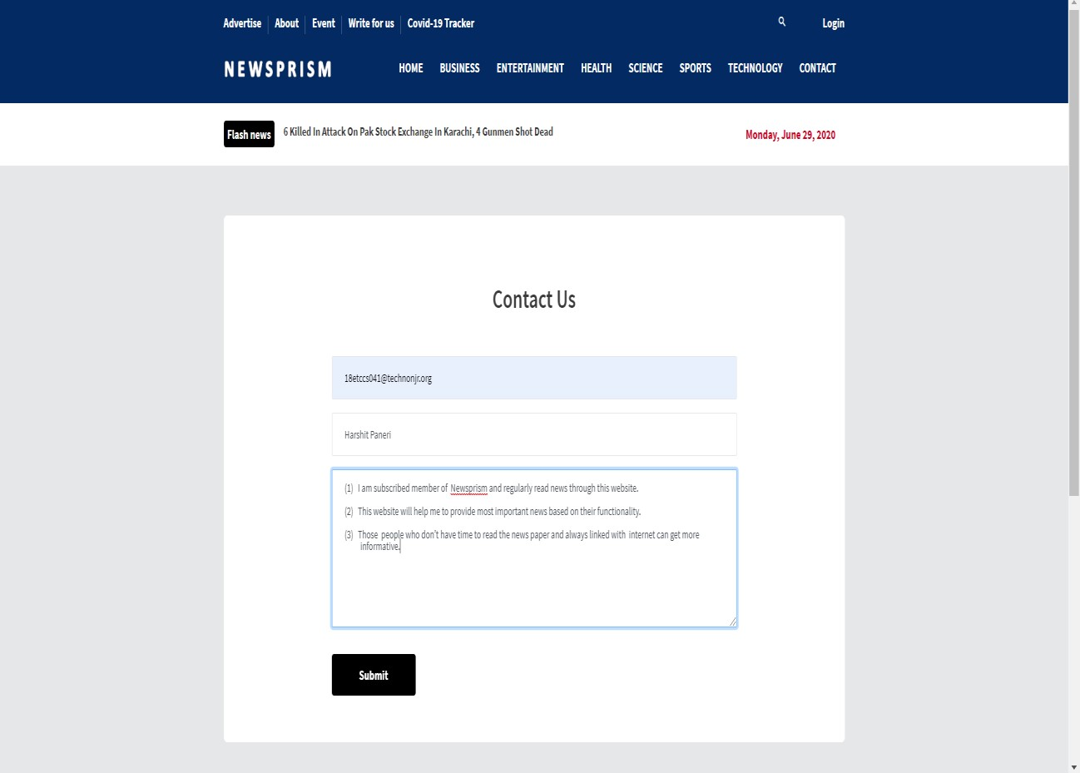

#### Fig 4.9 – Contact Us Page

It could be beneficial to let your visitor decide what’s useful for them. It’s also helping the visitor to contact the website owner.

➢ **Header**



#### Fig 4.10 - Header

Header is the top section of the web page. Headers are often the first thing site visitors see so having the logo is important.

Footer

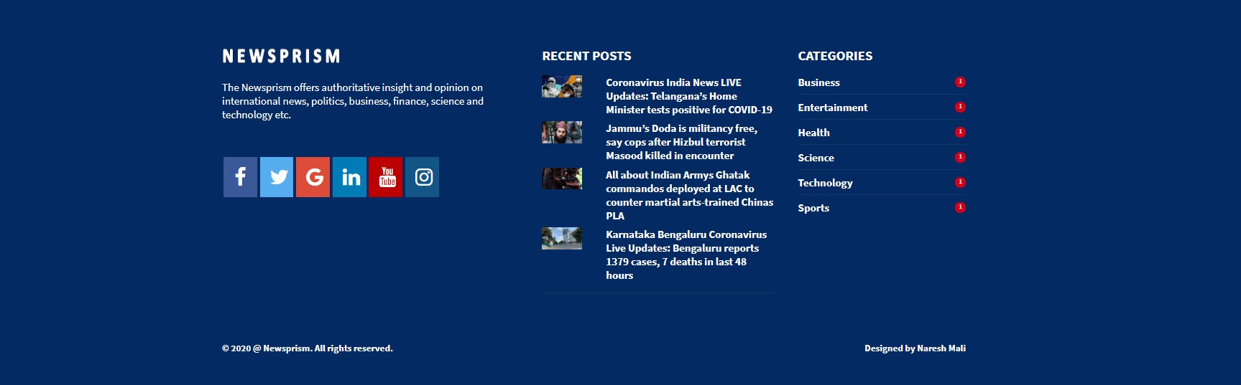

#### Fig 4.11 - Footer

The footer appears at the bottom of site page. It usually contains small-print items like copyright Information and footer design is about choosing what to include, with the intention to helping Visitors and meeting business goals.

➢ **About Us**

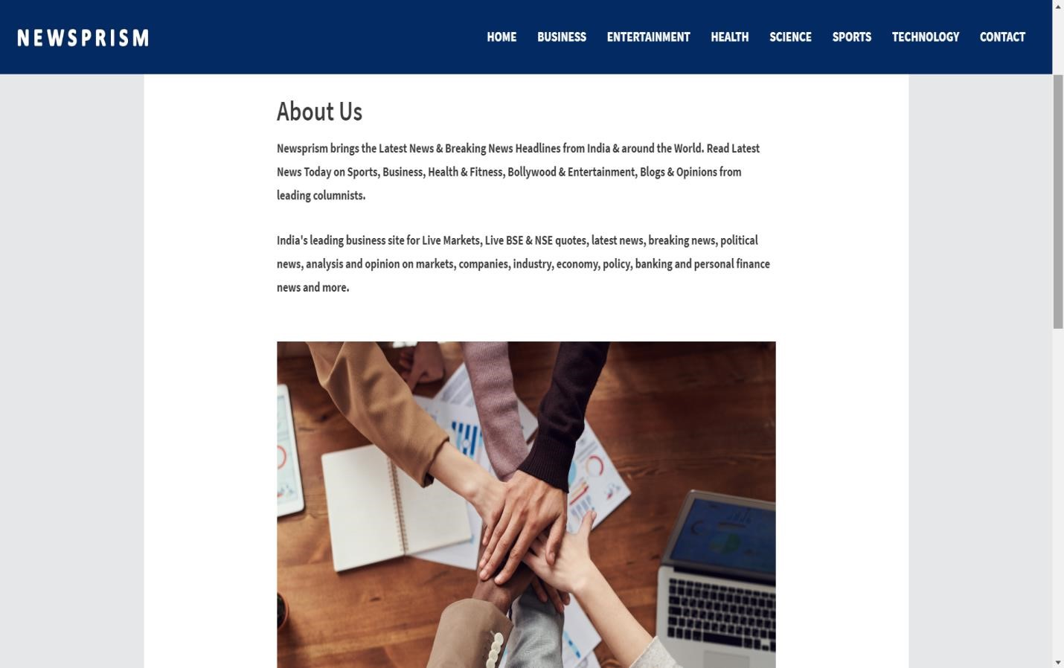

**Fig 4.12 - About Us Page**

CHAPTER – VI

TESTING

CHAPTER – VII

## CONCLUSION AND FUTURE ENHANCEMENTS

### 5.1. Conclusion

* To get information about current world ages anytime, anywhere, anyone can access by internet at low cost.
* Coverage of distribution and faster dissemination of information in a more timely manner.
* To provides a wonderful user interface that attracts more and more user.
* All new updated information that is more effective and useful for people.
* In our project work, an attempt has been made to develop a News or informationbased website. We develop this project that helps the people and make them aware so that they can know any news. To establish this website, we use various methodologies. To develop this project, we have faced many problems but we hardly tried to develop this project. Our training faculty helps us by giving his valuable opinion, decision and time.

### 5.2. Future Scope

In this we can make many further advancements and improvements to make it better. The more we attractive the website the more it will become better. And we can also integrate any kind of news according to our need. We will like for support systems, news systems, software’s, etc. In future we will do following work:

* We can add more security features in it.
* We can make any kind of user interface according to our need.
* We can add many kinds of APIs like Google, discovery APIs.
* We will develop this website for large volume.
* We update our database.
* We can make searching system more flexible.

CHAPTER – VIII

BIBLIOGRAPHY

**Bibliography**

We are using various type of books and websites from which we get the Knowledge about

MEAN Stack which are following: -

1. Fundamentals of Software Engineering. New Delhi: Prentice-Hall India.
2. Software Engineering, Girdhari Singh, ShaliniPuri.
3. Fundamental of Software Engineering Rajib mall, Phi.
4. Full-Stack JavaScript Development with MEAN
5. https://angular.io
6. WWW.Google.com 7. WWW.W3schools.com
7. Photoshop.
8. [https://nodejs.org](https://nodejs.org/)
9. [www.tutorialspoint.com](http://www.tutorialspoint.com/)
10. [www.wikipedia.org](http://www.wikipedia.org/)